Live Request Integration – SOAPUI

Please follow the below instructions to perform Live request using the SOAPUI

- Open SOAP UI tool
- Click SOAP option as shown below
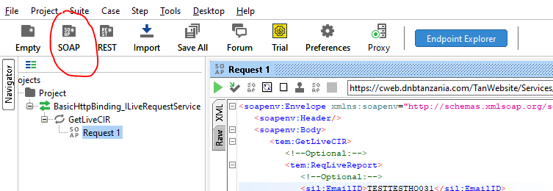

- Enter Name of the project in Project Name
- And provide WSDL URL in Initial WSDL text box
- Click OK to proceed further.
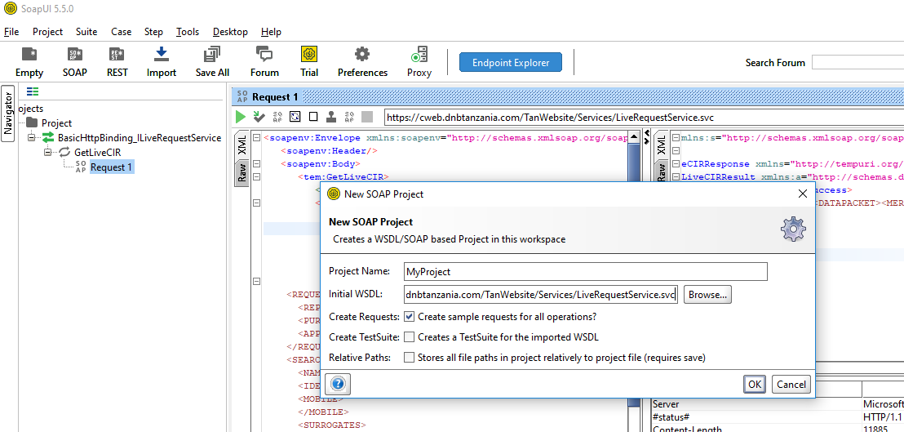

- Double click on Request as circled in Red colour
- Provide URL in text box as shown in highlighted in yellow colour
- Execute the request by clicking Run button. The response will be shown in right panel.
